INTRODUCTION TO DATA MANAGEMENT
PROJECT REPORT
(Project Semester January-April 2025)
ON

ROAD AND BRIDGE DEVELOPMENT STATUS USING EXCEL DASHBOARD

Submitted by

Himanshu Kholiya

Registration No 12319023

Programme and Section : B.Tech (K23GS)
Course Code : INT217

Under the Guidance of

Baljinder Kaur(UID : 27952)

Discipline of CSE/IT

Lovely School of Computer Science and Engineering

Lovely Professional University, Phagwara

CERTIFICATE

This is to certify that Himanshu Kholiya bearing Registration no. 12319023 has completed Int217 project titled, “Road and Bridge Development Status using Excel Dashboard” under my guidance and supervision. To the best of my knowledge, the present work is the result of his/her original development, effort and study.

Signature and Name of the Supervisor
Designation of the Supervisor
School of Computer Science And Engineering
Lovely Professional University
Phagwara, Punjab.

Date: 13-04-2025

DECLARATION

I, Himanshu Kholiya, student of B.Tech under CSE/IT Discipline at, Lovely Professional University, Punjab, hereby declare that all the information furnished in this project report is based on my own intensive work and is genuine.


Date: 13-04-2025 Signature
Registration No. 12319023 Name of the student: Himanshu Kholiya

ACKNOWLEDGEMENT
I would want to take this time to sincerely thank everyone who helped to make this project, "Road and Bridge Development Status using Excel Dashboard" a success. I owe a debt of gratitude to my project mentor, Baljinder Kaur, whose wise counsel, perceptive recommendations, and unwavering support have been invaluable during this endeavor. Their knowledge and helpful criticism significantly improved the caliber and scope of this effort. Additionally, I would want to express my gratitude to the Computer Science and Engineering department of LPU for offering the resources and a supportive learning environment required to carry out this analytical study. The authors of the public crime dataset, whose work in gathering and preserving extensive crime-related data provided the basis for our analysis, also deserve my heartfelt gratitude. I am particularly appreciative of Microsoft Excel's creators for providing users with strong analytical tools like pivot tables and charts, which greatly facilitated the dataset's display and comprehension. Finally, I would want to express my sincere gratitude to my peers and family for their unwavering encouragement and spiritual support during this effort.

Abstract

The present project focuses on a comprehensive analytical study of infrastructure development data, specifically examining road and bridge projects across various administrative regions, using Microsoft Excel as the primary platform for data management, analysis, and visualization. In today’s world, infrastructure forms the foundation of societal progress and economic growth, and roads and bridges are among the most critical components enabling connectivity, trade, mobility, and social integration. Given the significance of these assets, their planning, monitoring, execution, and evaluation require both technical accuracy and administrative diligence. This project aims to showcase how a real-world dataset—often complex, unstructured, and multidimensional—can be systematically processed and analyzed using the inbuilt functionalities of Microsoft Excel. The dataset under study contains a variety of attributes including administrative classifications (District, Block, Panchayat, and Village), project-specific details (Work Name, Type of Work, Financial Year, and Scheme), financial parameters (Sanction Amount and Technical Sanction Amount), timelines (Work Start Date and Completion Date), and progress tracking (Work Status). Each of these fields contributes to building a robust understanding of how infrastructure projects are conceived, funded, managed, and completed across diverse regions. In this project, Excel’s comprehensive capabilities were employed not just for basic tabular organization, but for higher-level data manipulation, statistical summarization, and visual storytelling through graphs and charts. Tools like Pivot Tables, conditional formatting, logical functions, and date-based formulas were extensively applied to ensure that the data was both accurately interpreted and meaningfully presented. The project also emphasizes the importance of data cleaning, as real-world datasets often contain inconsistencies, errors, or missing information, which can significantly affect the integrity of any subsequent analysis. Additionally, visual tools such as bar charts, pie charts, and line graphs were used to highlight patterns, trends, and anomalies within the data, allowing for easier interpretation of the insights derived. Ultimately, the project underscores the power of structured data analysis in decision-making processes related to infrastructure development. The findings of this study not only provide a clearer picture of the current status and financial health of the projects but also offer a strong foundation for further research, future forecasting, and effective resource allocation planning.

- INTRODUCTION
Infrastructure plays a crucial role in the socio-economic development of any nation. In India, road and bridge connectivity is vital for enhancing accessibility to rural and remote regions, enabling better transport, trade, and overall development. To address these needs, the Government of India initiated the Pradhan Mantri Gram Sadak Yojana (PMGSY), which aims to provide all-weather road connectivity in rural areas. The program has evolved through multiple phases—PMGSY-I, PMGSY-II, and PMGSY-III—each targeting different goals based on development priorities and regional requirements.
This project aims to analyze the implementation progress of road and bridge infrastructure projects under the PMGSY schemes. It focuses on both physical metrics (such as the number of roads and bridges completed) and financial metrics (including sanctioned costs and expenditures). Through state-wise and scheme-wise analysis, the project highlights successful areas of implementation as well as those requiring improvement. The findings are based on a dataset that captures key indicators like sanctioned and completed infrastructure, costs incurred, and completion percentages across various Indian states and union territories.
The primary objective of this analysis is to provide insights into the execution of infrastructure development, identify gaps, and suggest directions for enhanced planning and policy implementation.

- SOURCE OF DATASET
https://www.data.gov.in/catalog/pradhan-mantri-gram-sadak-yojna-pmgsy
- DATASET PREPROCESING

- Did the changes in the names of columns for easy access and removed the extra spaces.
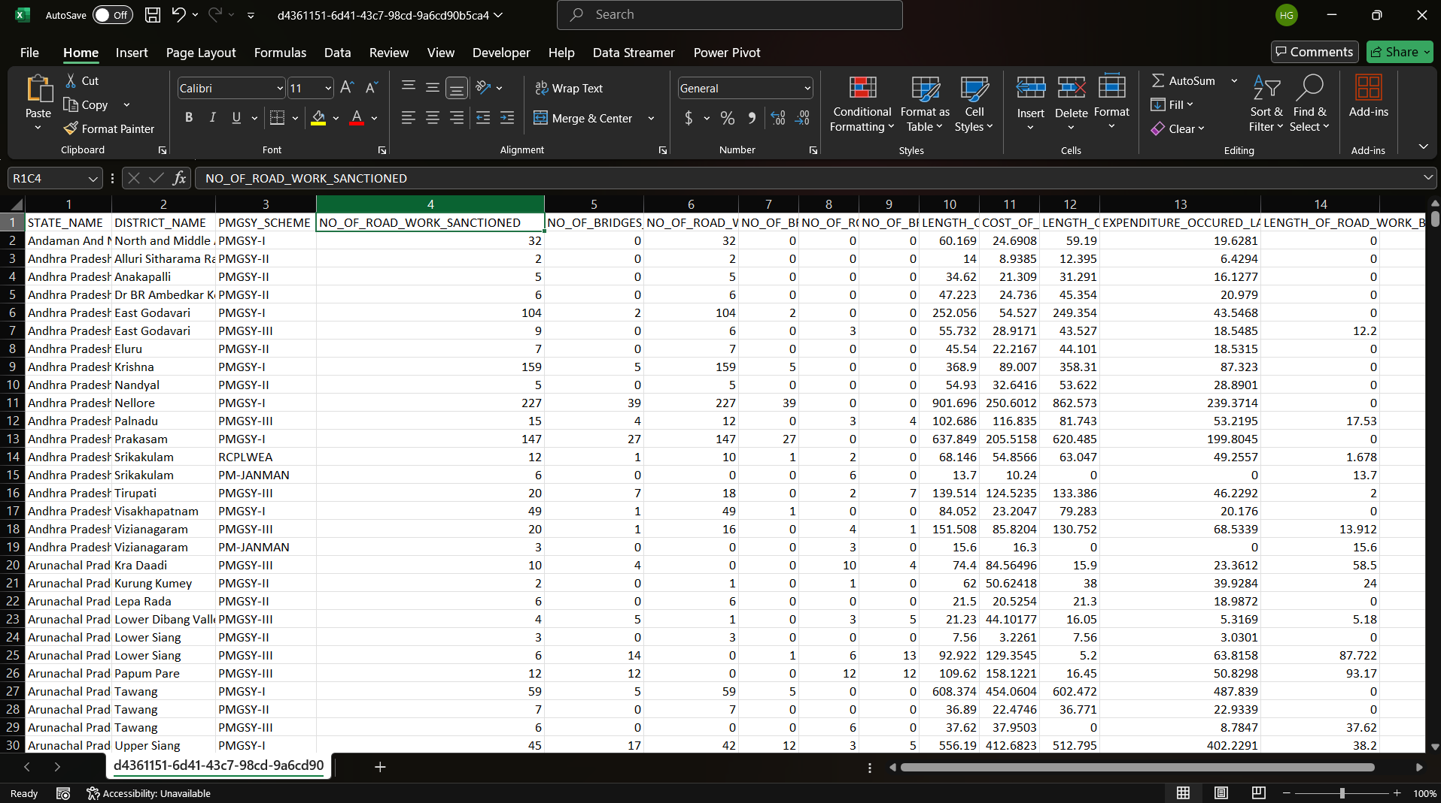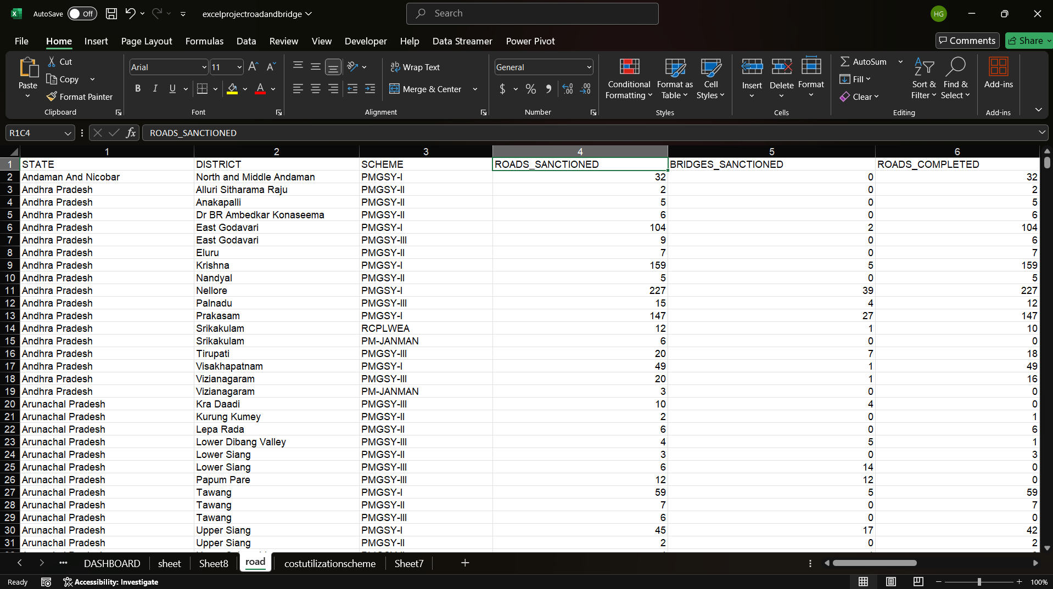

- Added one more columns for extra insights.
- Completion %
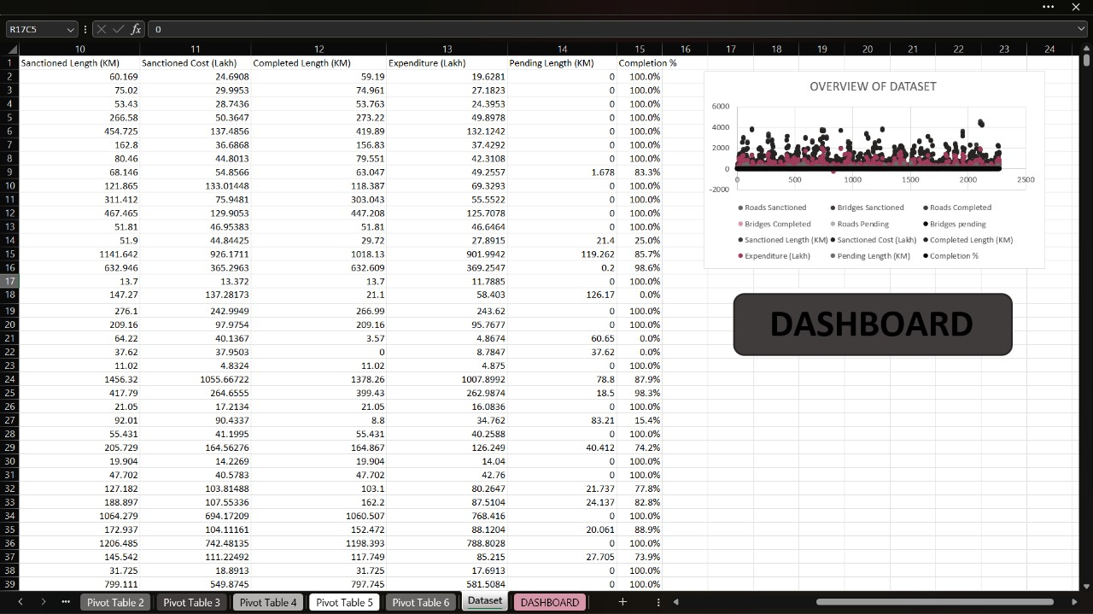

- Added one more table using the reference of pivot table 3.

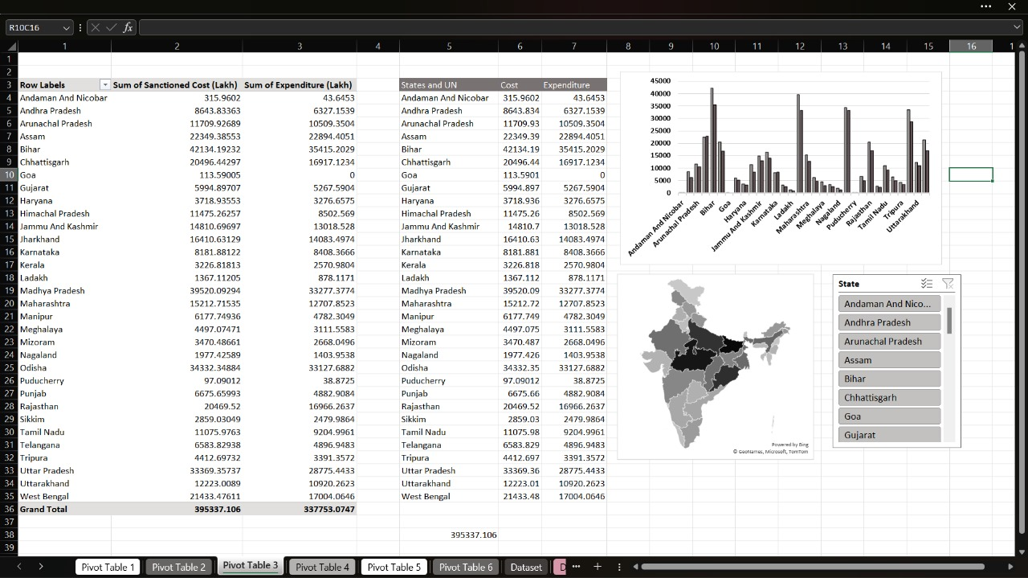

- ANALYSIS ON DATASET
- General Description
The dataset includes information from all Indian states and union territories. Key variables include:
- Number of roads/bridges sanctioned and completed
- Sanctioned costs and expenditures (in Lakhs)
- Scheme categorization (PMGSY-I, II, III,RCPLWEA,PM-JANMAN)
The data spans multiple years and provides both financial and execution metrics.
- Specific Requirements
The goal was to:
- Evaluate state-wise and scheme-wise completion rates
- Identify underperforming and overperforming states
- Assess fund utilization efficiency

- Analysis Results
The data analysis showed significant variation in performance across states in both road and bridge construction. States like Assam, Bihar, and Andhra Pradesh emerged as top performers in road completion rates, each achieving above 90% completion, with Assam nearly reaching full completion. Arunachal Pradesh showed moderate performance with over 85% of roads completed, while Andaman and Nicobar Islands had a notably low road completion percentage of just under 60%, indicating a need for targeted intervention.
In terms of bridge construction, Assam again demonstrated outstanding performance with nearly 97% of its sanctioned bridges completed. Andhra Pradesh, Bihar, and Arunachal Pradesh showed respectable bridge completion percentages in the range of 70% to 75%, suggesting consistent progress. However, some regions, like the Andaman and Nicobar Islands, reported no bridge completions, highlighting areas of concern or lack of sanctioned projects.
When analyzing the financial aspect of the data, it was observed that PMGSY-I has the highest levels of both sanctioned and expended funds, reflecting its longer duration and more mature implementation. PMGSY-II and PMGSY-III follow, with relatively lower fund utilization, potentially due to their more recent initiation or ongoing implementation challenges. These findings help identify states and schemes where infrastructure development is on track and those that require further support or reevaluation.
- Visualization

- COLUMN CHART AND DONUT CHART SHOWING THE NUMBER OF ROADS AND BRIDGES SANCTIONED TO SCHEMES
Give the scheme-wise project overview
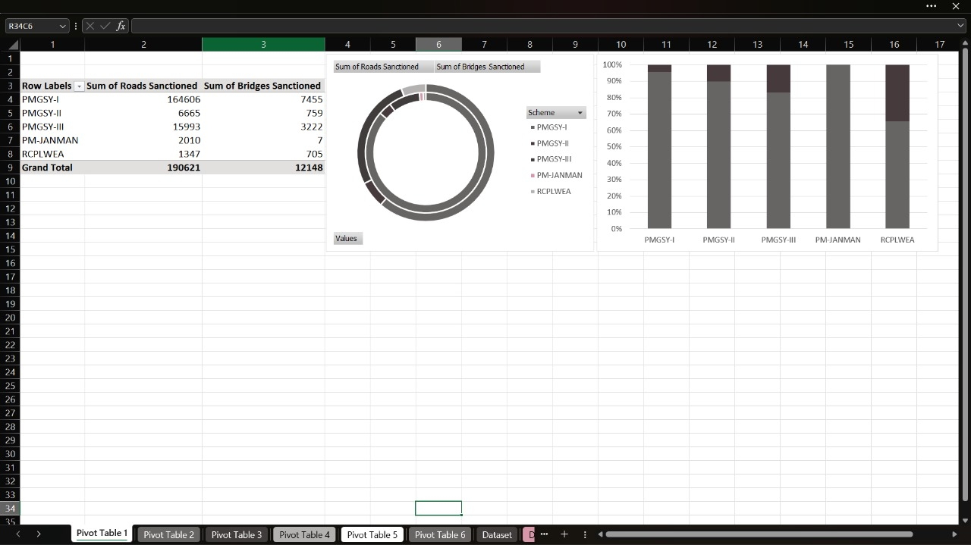

- AREA CHART SHOWING NUMBER OF ROADS AND BRIDGES COMPLETED IN EACH STATE
Tells top 10 states with the highest infrastructure
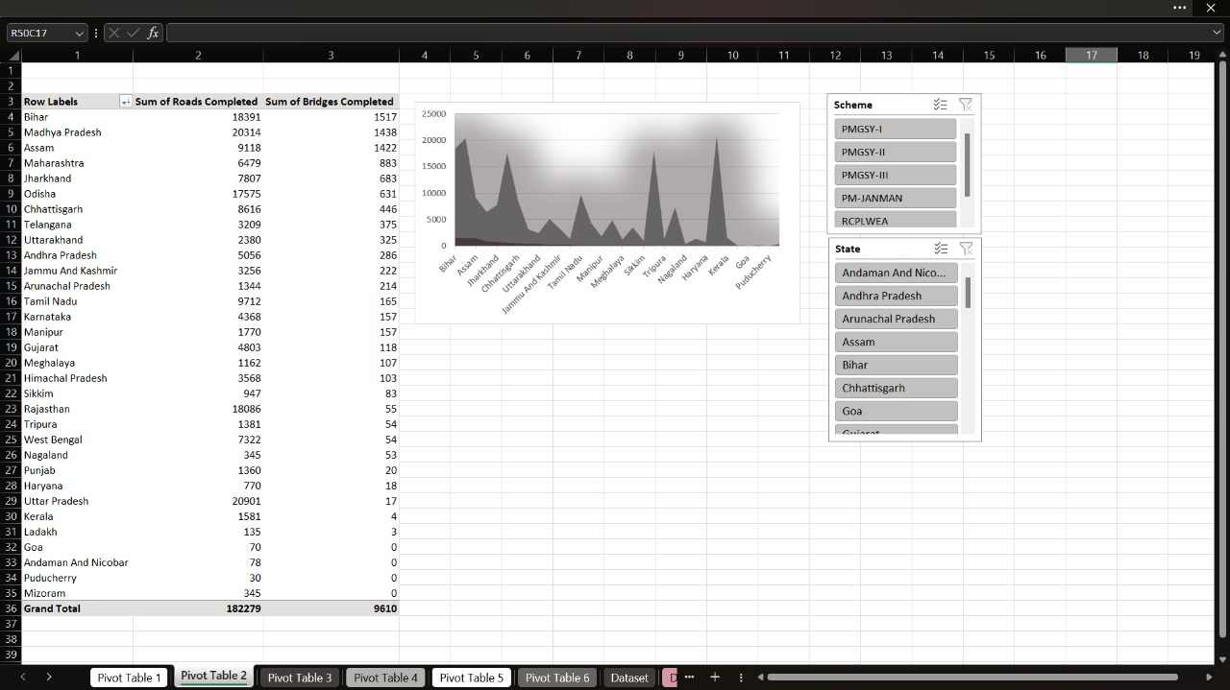

- COLUMN CHART SHOWING THE AMOUNT OF MONEY (IN LAKHS) SACTIONED TO THE STATE AND THE EXPENDITURE OCCURRED (ALSO USES MAP CHART AND SLICERS FOR STATES).

- COLUMN GRAPHS SHOWING TOP DISTRICT WITH THE HIGH PENDING ROADS
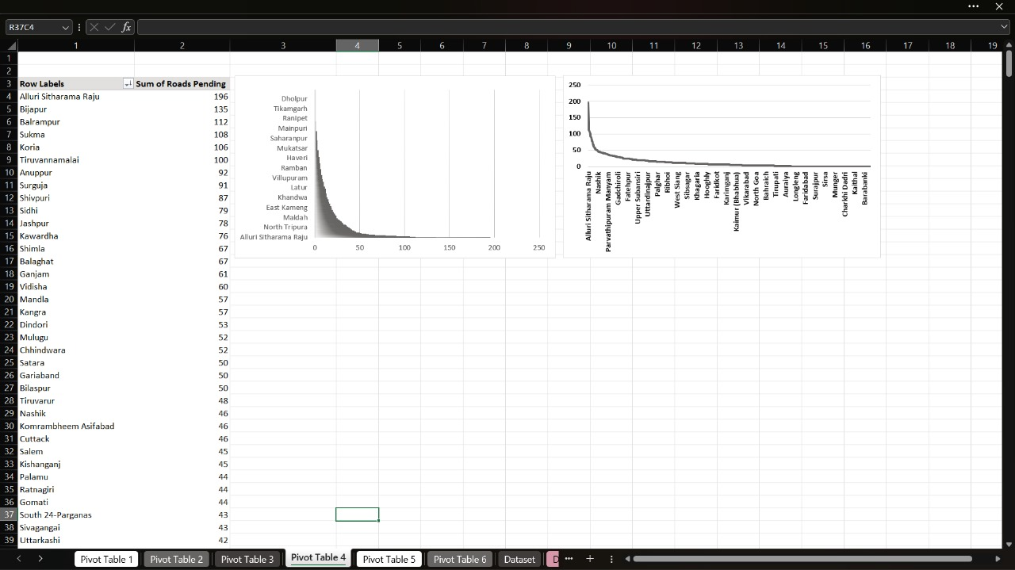

- DONAT GRAPH AND COLUMN GRAPH SHOWING COMPARISON BETWEEN SCHEMES, HOW MANY ROADS SANCTIONED AND HOW MANY THEY COMPLETED.
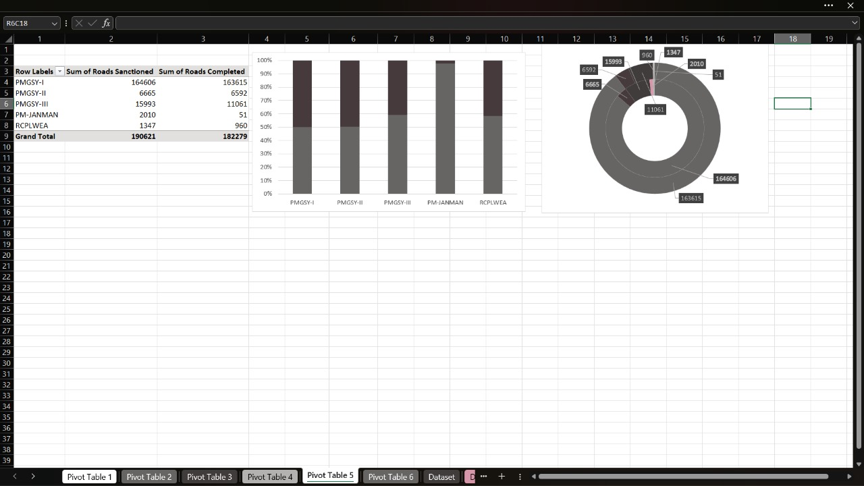

- LINE GRAPG SHOWING LENGTH OF THE ROADS SANCTIONED AND LENGTH OF THE ROADS COMPLETED BY STATES.
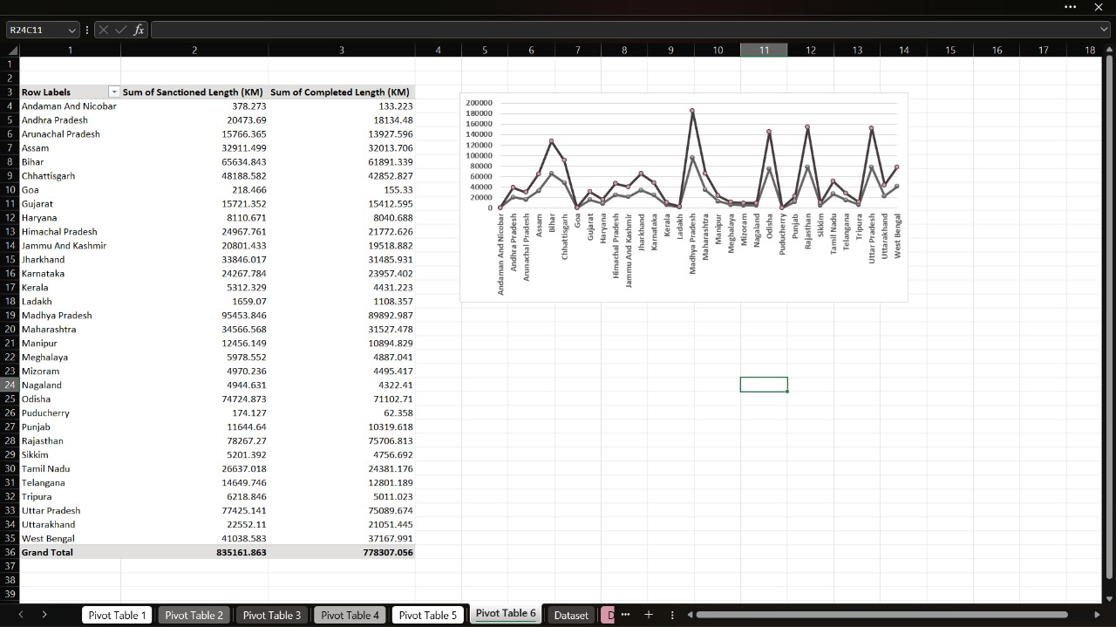

- CONCLUSION
In conclusion, the project provides valuable insights into the status and effectiveness of road and bridge construction projects under the PMGSY schemes across India. The findings highlight notable disparities among states in terms of infrastructure development, with certain states like Assam, Bihar, and Andhra Pradesh demonstrating strong performance through high completion percentages. These achievements underscore successful planning and execution efforts. On the other hand, regions like the Andaman and Nicobar Islands show considerable lag, signaling the need for additional attention, resources, or revised strategies.
From a financial standpoint, PMGSY-I emerges as the most established and effectively implemented scheme, exhibiting substantial fund utilization. The relatively lower financial engagement in PMGSY-II and PMGSY-III points to either recent launch phases or administrative challenges that may be hindering progress. This comprehensive analysis not only reflects the current state of rural infrastructure but also emphasizes the importance of continuous data monitoring, targeted intervention, and strategic allocation of resources to ensure balanced development across all regions. As infrastructure plays a pivotal role in socio-economic growth, such evaluations can contribute meaningfully to policy-making and program optimization.

- FUTURE SCOPE
- Integrate real-time monitoring systems with dashboards.
- Analyze environmental and social impacts of infrastructure.
- Incorporate predictive models for better resource allocation.
- REFERENCES
[1] Ministry of Rural Development, Government of India. [2] PMGSY Official Portal. [3] Microsoft Excel Documnetation [4] IEEE citation style documentation.

DASHBOARD

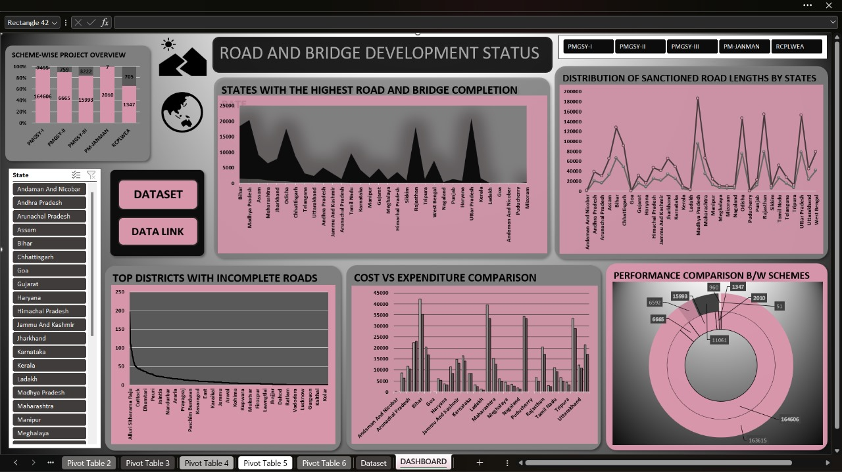

LinkedIn Link: https://www.linkedin.com/posts/himanshu-kholiya-0ab5aa262_datavisualization-dashboarddesign-exceldashboard-activity-7317134284551569408-9ivP?utm_source=social_share_send&utm_medium=android_app&rcm=ACoAAECECgMBtuZDwozdBl09WtbtiNsQ2vU9jo0&utm_campaign=whatsapp


